means, standard deviations, zero-order correlation coefficients, beta weights, intercept and unstandardized slopes, multiple *R2*, *p* values, and a confidence interval for *R2*.  Be sure to refer to the table.

|  |  |  |  |  |  |  |
| --- | --- | --- | --- | --- | --- | --- |
| Table 1 | | | | | | |
| *Predicting Catch from Priapam and Koleos in the Water (N = 200)* | | | | | | |
|  | Zero-Order *r* | | | *β* | *sr2* | *B* |
| Variable | Priapam | Koleos | Catch |
| Priapam |  | -.047 | .23* | 12.29* | .22 | 1.24* |
| Koleos |  |  | -.05 | -2.13 | -0.04 | -0.22 |
|  |  |  |  | Intercept = | | 160.72 |
| *M* | 150.34 | 150.28 | 314.70 |  |  |  |
| *SD* | 9.89 | 9.75 | 54.65 | *R2* = | | 0.05* |

\**p* < .05

As shown in Table 1, Catch was positively correlated with Priapam, *r* = .23, *p* < .001, 95% CI [.09, .35]and negatively correlated with Koleos, *r* = -.05, *p* = .49, 95% CI [-.19, .09].Priapam was negatively correlated with Koleos, *r* = -.047, *p* = .51, 95% CI [-.18, ..09].

Multiple regression was employed to relate Catch to Priapam and Koleos**.** The overall model was statistically significant, *R* = .05, *F*(2, 197) = 5.5, *p* < .001. **Emotional exhaustion was positively related to surface acting and negatively related to PsyCap, and PsyCap significantly moderated the effect of surface acting (see Table 2). The interaction is depicted in Figure 1. The standardized slope for the effect of surface acting was significant (*p* < .001) when PsyCap was one *SD* below the mean (β = .488), at the mean (β = .388), and one *SD* above the mean (β = .287). As the level of PsyCap increased, the strength of the relationship between surface acting and emotional exhaustion decreased.**

An additional multiple regression was employed to relate Catch to, **with interaction terms included for the potential moderation effects of PsyCap. Hypothesis 2 was partially supported. For emotional exhaustion, the overall model was statistically significant, *R* = .550, *F*(5, 410) = 35.582, *p* < .001. Emotional exhaustion was positively related to surface acting and negatively related to PsyCap, and PsyCap significantly moderated the effect of surface acting (see Table 2). The interaction is depicted in Figure 1. The standardized slope for the effect of surface acting was significant (*p* < .001) when PsyCap was one *SD* below the mean (β = .488), at the mean (β = .388), and one *SD* above the mean (β = .287). As the level of PsyCap increased, the strength of the relationship between surface acting and emotional exhaustion decreased.**

***Figure 1.*** Koleos as a moderator between Catch and Priapam. All variables were standardized to mean 0, variance 1.

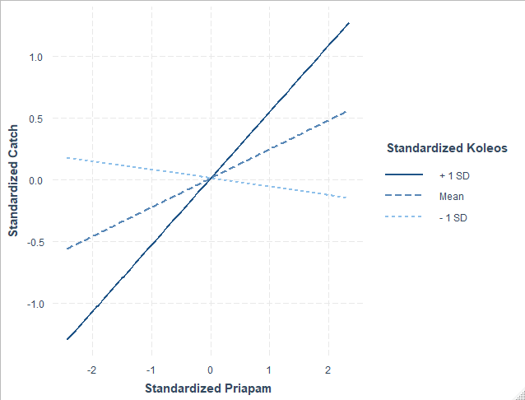

    Here are some common errors to avoid:

* Not reporting *F*, *df*, and *p* for the multiple regression.
* Not reporting a confidence interval for the *R2*.
* Not reporting the *sr2* and *t* or *F* test of the interaction.
* Not indicating which of the simple slopes were significant.